4. Modes of DES
Aim
To implement different DES modes of operation.
Types of DES Modes
- ECB (Electronic Code Book)
- CBC (Cipher Block Chaining)
- CFB (Cipher Feedback)
- OFB (Output Feedback)
- CTR (Counter Mode)
ECB MODE:
Code:
text = input('Enter plaintext: ')
key = input('Enter key: ')
cipher = []
for i in range(len(text)):
cipher.append(ord(text[i]) ^ ord(key[i % len(key)]))
print('ECB Cipher (Hex):', ' '.join(format(x, '02X') for x in cipher))
Output:
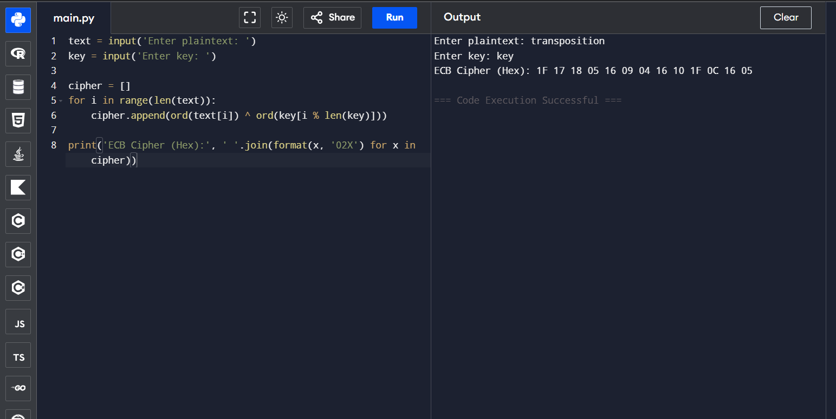

CBC MODE:
Code:
text = input('Enter plaintext: ')
key = input('Enter key: ')
iv = 7
cipher = []
prev = iv
for ch in text:
c = ord(ch) ^ prev ^ ord(key[0])
cipher.append(c)
prev = c
print('CBC Cipher (Hex):', ' '.join(format(x, '02X') for x in cipher))
Output:
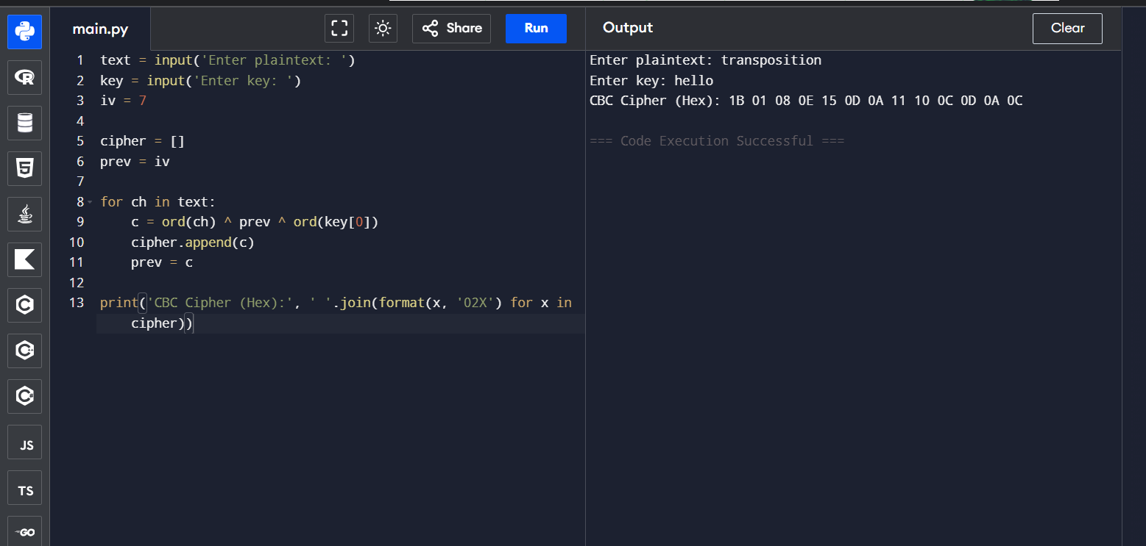

CFB MODE:
Code:
text = input('Enter plaintext: ')
key = input('Enter key: ')
feedback = 5
cipher = []
for ch in text:
c = ord(ch) ^ feedback ^ ord(key[0])
cipher.append(c)
feedback = c
print('CFB Cipher (Hex):', ' '.join(format(x, '02X') for x in cipher))
Output:
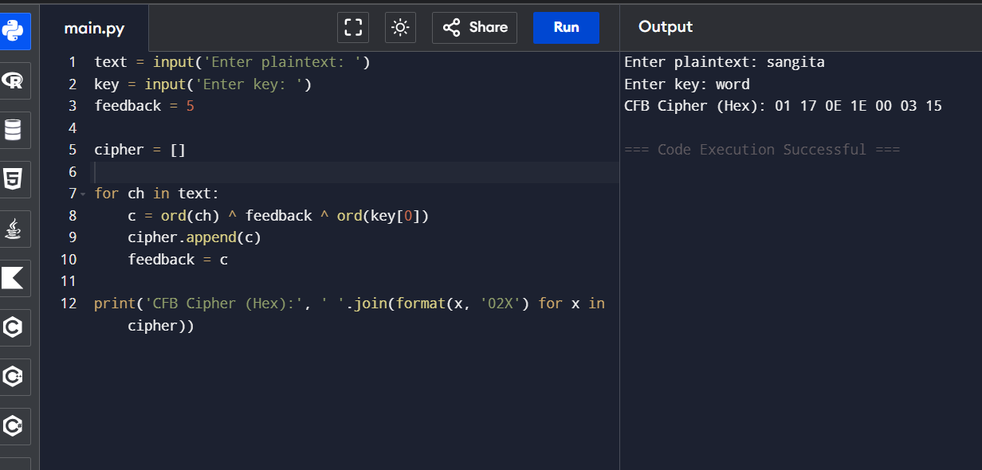

OFB MODE:
Code:
text = input('Enter plaintext: ')
key = input('Enter key: ')
stream = 5
cipher = []
for ch in text:
stream = stream ^ ord(key[0])
cipher.append(ord(ch) ^ stream)
print('OFB Cipher (Hex):', ' '.join(format(x, '02X') for x in cipher))
Output:
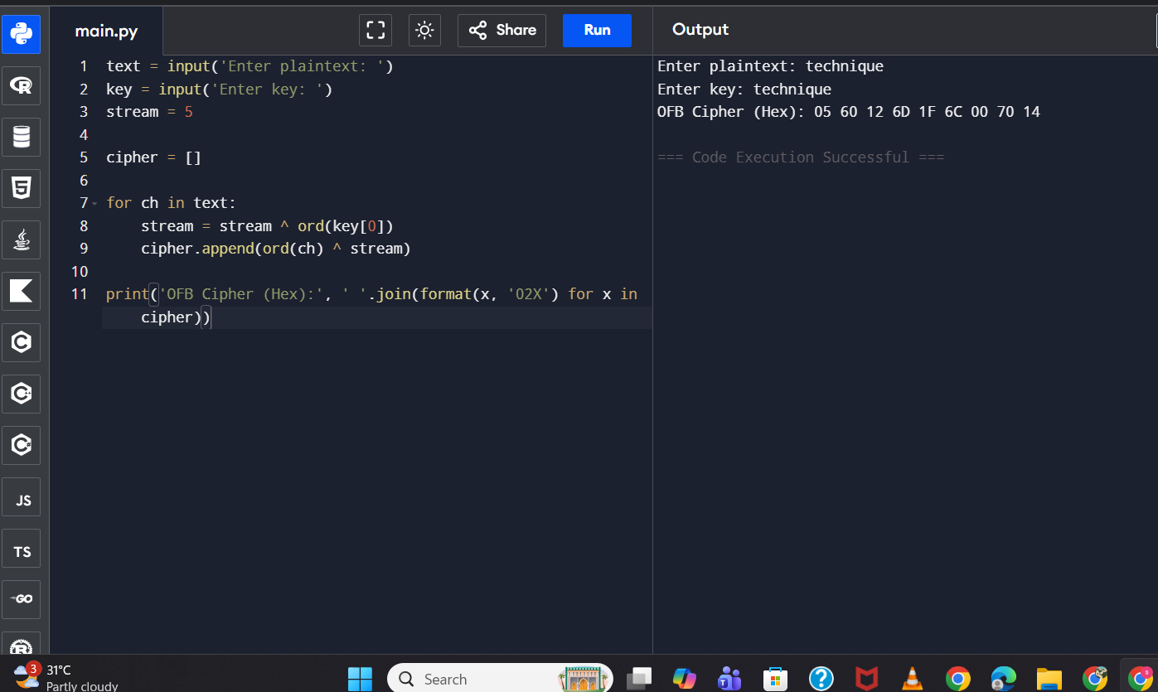

CTR MODE:
Code:
text = input('Enter plaintext: ')
key = input('Enter key: ')
counter = 1
cipher = []
for ch in text:
cipher.append(ord(ch) ^ (counter + ord(key[0])))
counter += 1
print('CTR Cipher (Hex):', ' '.join(format(x, '02X') for x in cipher))
Output:
